Graduate Student S26 Bus Pass Form
Graduate Students’ Association

University of Guelph graduate students who are not enrolled in their program of study during the summer semester but still wish to purchase a student bus pass for use during the S26 summer semester are eligible to do so should they meet two conditions:
- enrolled as a graduate student in their program of study during the previous Winter semester (W26)/paid the GSA Fee, and
- intend to re-enroll in their program of study for the upcoming Fall semester (F26)
To verify that the first condition is met, please send an image or PDF printout from WebAdvisor showing your W26 semester enrollment and GSA student fee payment (“Grad Association Fee”) to gsavpext@uoguelph.ca along with this completed form. Please omit any additional information as necessary to ensure your privacy. I have included an example on the second page that may be used for reference.
Once your form has been signed by the GSA VP Community Engagement, please bring a printout (hard copy) of the first page of this form and $163.10 (cash only) to the Central Student Association’s (CSA’s) front office (University Centre room 274, directly opposite the south elevators on the second floor) to purchase your summer bus pass.

For student applicant to complete:
Full Name: |  | Student Number:
Program: |  | Department:

I, Name, state my intention to re-enroll in my graduate program for the F26 semester.
I certify that all of the above information is true and correct.

Student signature: |  | Date:

For GSA VP Community Engagement to complete:
The GSA VP Community Engagement confirms that this student was enrolled during the W26 semester, paid the GSA student fee during the W26 semester, and that this form is complete.

Signature: |  | Date:

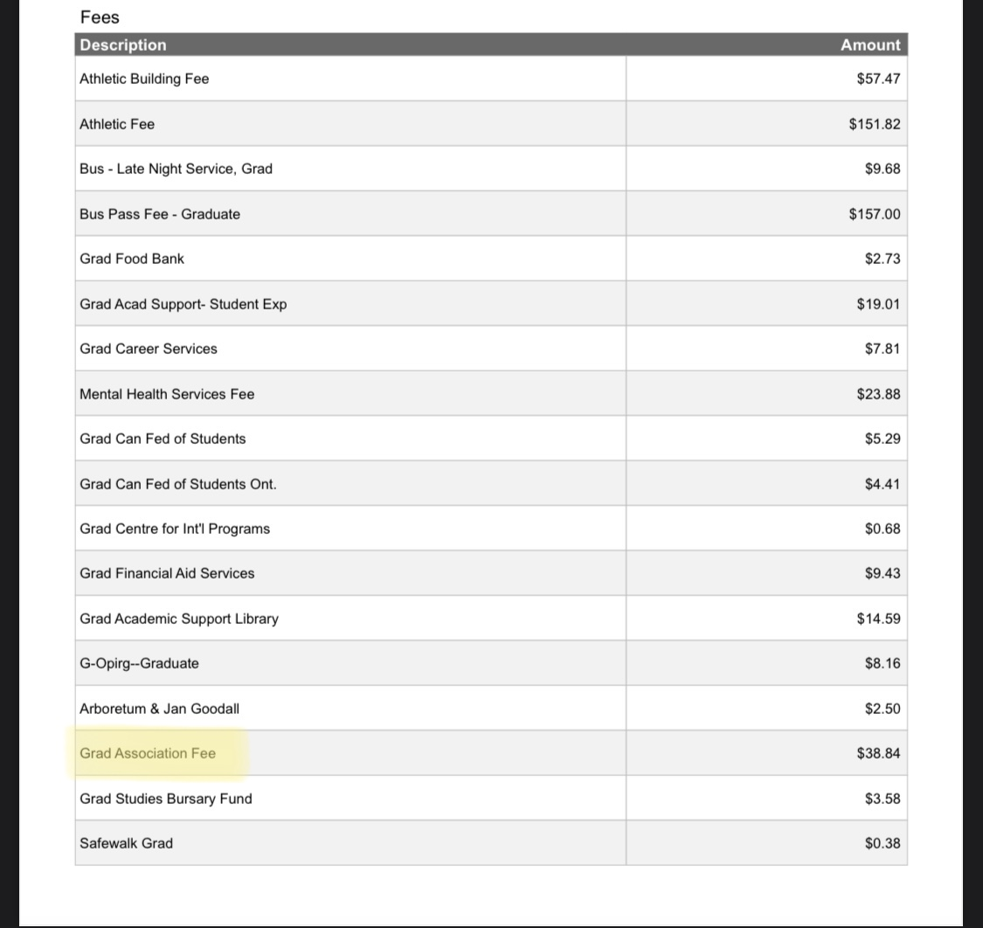
*DO NOT NEED TO PRINT THIS PAGE. FOR REFERENCE PURPOSES ONLY*

